BridgePoint/Matlab Integration

Phase I Final Report

Project Technology, Inc.
7400 N. Oracle Road
Suite 365
Tucson, AZ 85704

Contents
1. Contents 2
2. References 3
3. Introduction 3
3.1. Alternative Platform Technologies 3
3.2. Selected Platform 4
4. Possible Integration Implementations 4
4.1. Dedicated Matlab Editor Plug-in 4
4.1.1. Description 4
4.1.2. Benefits 6
4.1.3. Comments 7
4.1.4. Implementation Plan 7
4.1.5. Schedule 7
4.1.6. Cost 8
4.2. MC-2020 Integration with Matlab Code Generator 8
4.2.1. Description 8
4.2.2. Benefits 8
4.2.3. Comments 8
4.2.4. Implementation Plan 9
4.2.5. Schedule 9
4.2.6. Cost 9
4.3. Introducing Instance References 9
4.3.1. Description 9
4.3.2. Benefits 10
4.3.3. Comments 10
4.3.4. Implementation Plan 10
4.3.5. Schedule 10
4.3.6. Cost 10
4.4. Introducing Array syntax 10
4.4.1. Description 10
4.4.2. Benefits 11
4.4.3. Comments 11
4.4.4. Implementation Plan 11
4.4.5. Schedule 11
4.4.6. Cost 11
4.5. Embedded Matlab Command Window Plug-in 11
4.5.1. Description 11
4.5.2. Benefits 12
4.5.3. Discussion 12
4.5.4. Implementation Plan 13
4.5.5. Schedule 13
4.5.6. Cost 13

References
[1] Lockheed Martin Space Systems Statement of Work, AST-IRAD-02-03
[2] Eclipse http://www.eclipse.org/

Introduction
This report is part of the deliverable of a research contract between Lockheed Martin Space Systems and Project Technology [1]. This statement of work calls for an analysis of possible implementations for electronic integration of the BridgePoint modeling tool, Model Builder, and the Matlab mathematical analysis tool. This report documents the results of that analysis.
The demonstration software accompanying this report provides the other deliverable of the above statement of work. This software proves the feasibility of using Matlab m-files to specify the required behavior of BridgePoint transformers (operations) and other modeled action semantics. This report also provides Lockheed Martin with a "shopping list" from which they can select the integration(s) they want to see implemented. The selected features will then be integrated into the BridgePoint tool suite during 2004 and first quarter 2005.
The possible integration implementations described below are not all mutually exclusive; indeed many of them are complementary. Hence, during the demonstration of the software Project Technology shall provide suggestions for coherent groups of work packages that will provide Lockheed Martin with a comprehensive set of choices that can be made based on other technology selections (e.g. choice of language).

Alternative Platform Technologies
Two platform technologies were considered; the existing BridgePoint Model Builder tool (version 6) and the next generation BridgePoint development suite. These technologies were considered for integration with Matlab, both for the purposes of the demonstration deliverable required by the Statement of Work and for the longer term deliverable.
The alternative environment considered was the next generation BridgePoint development suite (BridgePoint 7.0). The next generation product suite is based on Eclipse, defined as ‘a kind of universal tool platform - an open extensible IDE for anything and nothing in particular’ [2]. Eclipse was designed to meet amongst others, the following requirements:
- Support the construction of a variety of tools for application development.
- Support an unrestricted set of tool providers, including independent software vendors (ISV’s).
- Support tools to manipulate arbitrary content types (e.g., Ada, C++, HTML, Java, C, JSP, EJB, XML, and GIF).
- Facilitate seamless integration of tools within and across different content types and tool providers.
- Provide a consistent interface for all integrated tools.
The above design goals mean that using a BridgePoint 7.0 based environment, Lockheed Martin will be able to combine other Eclipse aware tools into one fully integrated working environment, in addition to the Matlab integration proposed here.

Selected Platform
It is decided to use the next generation environment both for the demonstration software and as a platform for the proposed product-grade tooling support. This decision was made for four reasons:
- Project Technology is in the process of replacing the current tool suite based on the Eclipse platform. The deliverables proposed here will become available after the next generation tool suite is delivered.
- The next generation tool suite is built in Java using a framework specifically designed to easily support integration with third party tools.
- Project Technology would not wish to deliver the specialized tool enhancements described in this document on a platform for which we had no long-term plans.

Possible Integration Implementations

Dedicated Matlab Editor Plug-in

Description
This work package allows the user to mark State Actions, Functions, Bridges, Operations (Transforms) and Derived Attributes as being specified in Matlab m-language. For action semantics marked in this way, BridgePoint automatically launches an editor specialized for editing m-files when the user performs an open operation. Metamodel action semantics attributes marked as m-files contain a path to the m-file specified, so that the architecture can pass the m-file location (or open and pass the contents of the file) to the Matlab code generator.
Two alternate editors are proposed, an external Matlab native editor (Figure 4.1.2) and an internal BridgePoint native m-file editor (Figure 4.1.1). In Figure 4.1.1, an internal editor below the class diagram shows the m-file contents in an editor panel embedded inside the new BridgePoint 7.0 environment. The editor page size is adjustable and can be maximized in the work area with a double click.
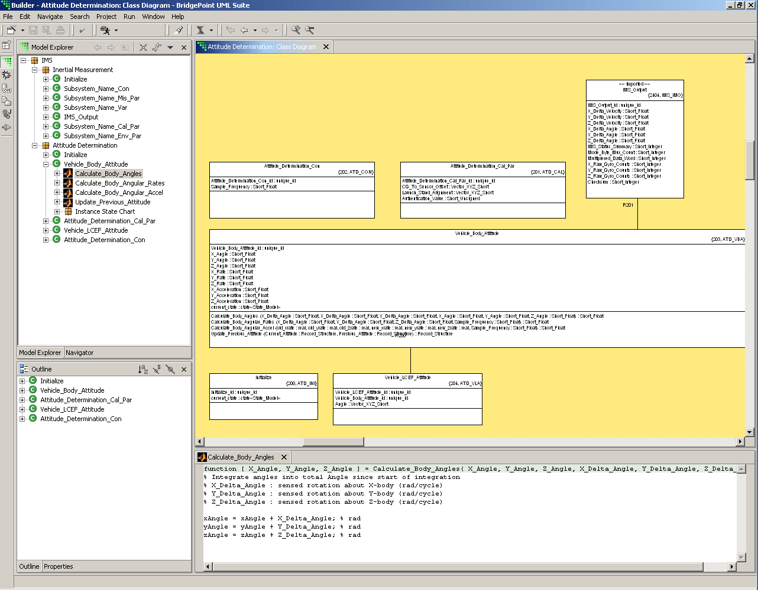
Figure 4.1.1: Internal M-File Editor
In Figure 4.1.2, a native Matlab editor is shown in its own window that appears on top of the BridgePoint 7.0 interface. As a separate window, it may be resized, moved around or demoted behind the BridgePoint application using normal window system commands.
The user selects which editor he wants to see from a menu (Figure 4.1.3). Once selected, the BridgePoint tool remembers the chosen editor, which can then be started using the simpler Open command or even just with a double click on the item. If the user later chooses a different editor, the tool can optionally remember the new editor or revert to the first selected editor. Action language bearing model elements whose behavior is specified as m-files may be differentiated from regular action language actions by the Matlab icon shown against them in the Model Explorer and Outline trees.

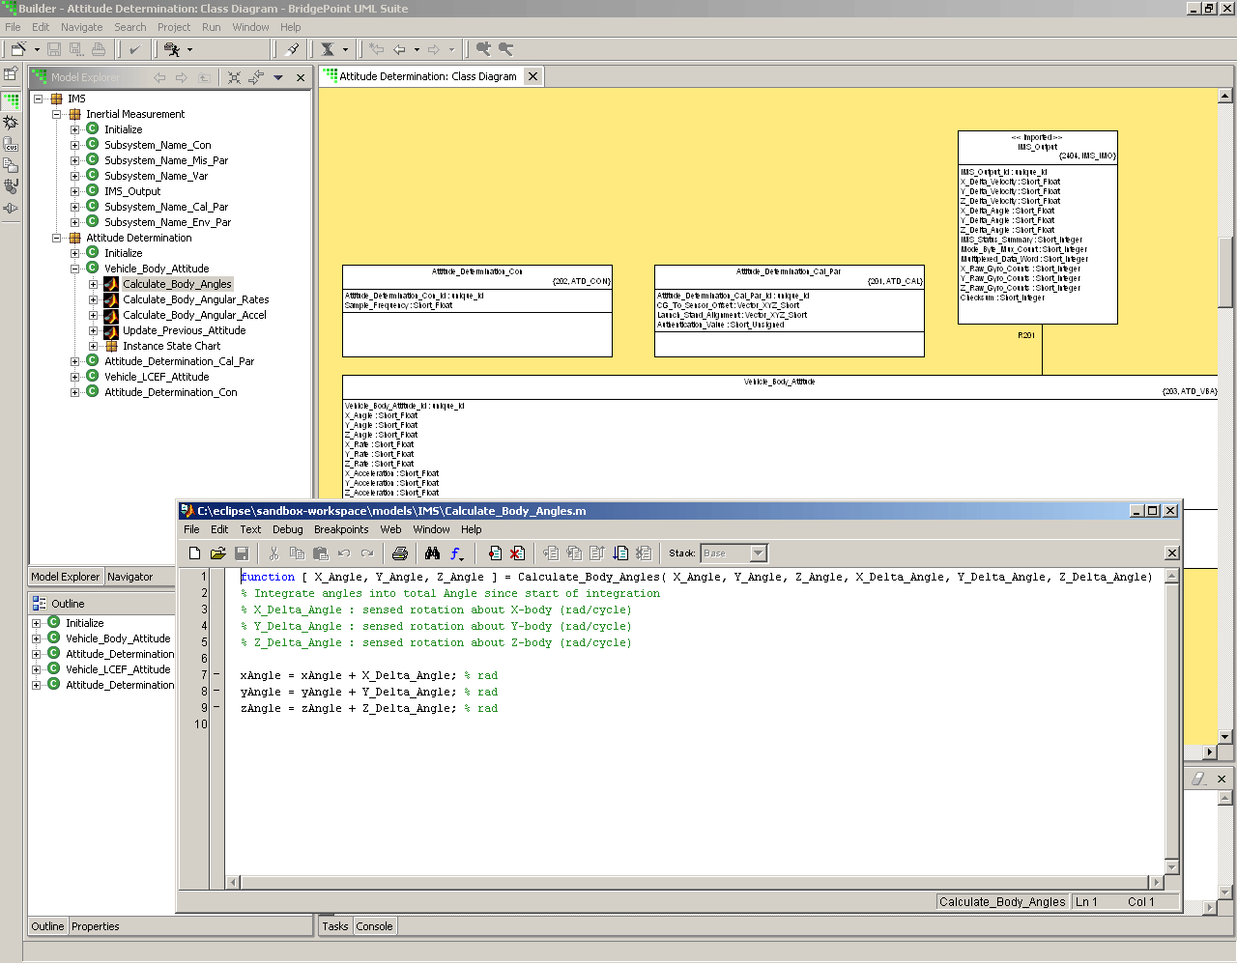
Figure 4.1.2: External Matlab Editor
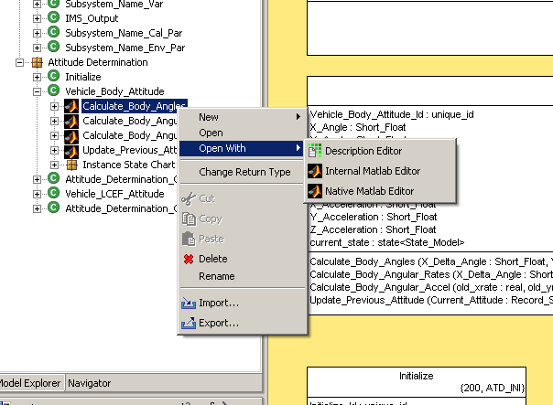
Figure 4.1.3: Choosing the required editor

Benefits
This is the minimum viable work item set. Omitting this work would effectively preclude integration between the tools.
Each of the editors has its own strengths. The external editor has the following advantage:
- m-file editing takes place in the familiar Mathworks editor environment.
- Since it is m-language syntax-aware, keywords are highlighted and auto completion and context sensitive help features are available.
The internal editor offers the following advantages:
- No local Matlab installation needed.
- Faster startup.
- Standard BridgePoint 7.0 book-marking and task annotations available.
- The editor integrates with the rest of the BridgePoint tool, giving the user the same flexibility of presentation options.

Comments
Both of the editors proposed above are provided in this work package because they are both seen as being useful in different environments and to different developer roles.
Each editor has limitations that are complemented by the capability of the other. The external editor has the following drawbacks:
- A local installation of Matlab is required for each seat that has a need to edit in this way.
- The time between opening the action semantics element and having the editor available is increased, particularly for the first time the editor is launched.
- The standard BridgePoint 7.0 book-marking and task features are unavailable.
- The editor appears in a separate window, which means that it is likely to be obscured every time a user interaction with BridgePoint is required.
- Changes to the m-file made with the internal editor cannot automatically cause the external editor to refresh.
The disadvantage of the internal editor is:
- No Matlab syntax highlighting or command completion.

Implementation Plan

Schedule
The time required to implement, test and document this feature is estimated to be 11 man weeks.

Cost
The cost to develop this feature is $55,000.

MC-2020 Integration with Matlab Code Generator

Description
This work package delivers product-strength integration between the Project Technology MC-2020 commercial model compiler and the Mathworks Matlab C++ code generator. The enhanced model compiler delivered by this work will recognize action semantics specified in m-language and read the path to the specified m-file contained in the model. It will pass this file (or its contents) to the Matlab code generator and will capture the Matlab generated code in a place already reserved for external code in the architecture. It will generate impedance-matching code that ensures that modeled arguments are passed to the Matlab generated functions correctly. Finally the enhanced model compiler will ensure that all necessary Mathworks include files are specified such that the Matlab generated code is seamlessly compiled and linked with the model compiler generated code to produce a single executable.

Benefits
- This project enables the use of commercial model compiler technology within the Lockheed Martin development organization. This offers economies of scale in that Project Technology takes on the maintenance burden of the model compiler.
- In addition, use of a commercial model compiler enables model level execution and debugging including breakpoints and single stepping through actions. This is achieved using the new Model Debugger product for observing and controlling execution of the generated executable.

Comments
This work package deliverable is of use even if it is decided that the project is to use Ada as its programming language. This is because the MC-2020 model compiler produces instrumented executable programs that can be used with Model Debugger to observe and control application execution, allowing compiled models to be debugged at the model level in a host environment. This feature is available in combination with Matlab generated functions, allowing the user to inspect values being passed to and values returned from algorithms specified in m-language.

Implementation Plan

Schedule
The time required to implement, test and document this feature is estimated to be 12 man weeks.

Cost
The cost to develop this feature is $60,000.

Introducing Instance References

Description
The notion of an instance handle set closely aligns with the Matlab concept of an array data type. BridgePoint Object Action Language (OAL) does not currently permit the passing of instance handle sets as event data or as arguments to operations, functions or bridges. These mechanisms, in particular bridge calls and operations, are the obvious locations for mapping modeled artifacts to Matlab functions. Not having an instance passing mechanism limits the ability to integrate BridgePoint and Matlab. The proposed solution is to modify the BridgePoint metamodel and action language so that instance handles and sets can be passed as arguments.
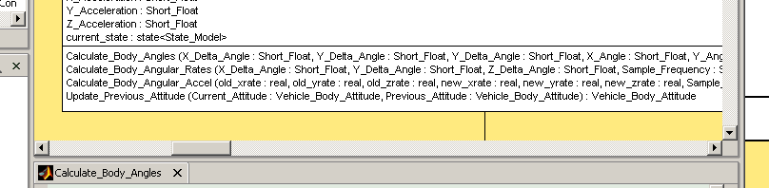
Figure 4.3.1: Instance reference arguments and return type
While introducing instance references as arguments, it is more efficient to implement instance references for all currently data typed model elements. Hence, this work package will apply the instance reference concept to the following areas:
- Attributes (Derived and Base)
- Bridge Arguments and return value
- Operation Arguments and return value (see Figure 4.3.1)
- Function Arguments and return value
- Event Data Items
- External Entity Data Items
- External Entity Event Data Items
Like arguments of other types, instance reference arguments shall be available both passed by value and passed by reference. In contrast with other argument types, instance reference arguments shall default to pass by reference. Note that the application of instance references to attributes also supports the concept of compound data types (i.e. a data item that holds a number of attribute values). The need for this feature is also in evidence within the Lockheed Martin sample models reviewed.

Benefits
- This enhancement allows concepts in Matlab to more seamlessly integrate with BridgePoint.
- Instance handle sets map directly onto arrays of compound data types in m-language.
- Also supports modeling with compound data types.

Comments
The need for instance reference parameters is inferred from the embedded Ada code inside the supplied sample Lockheed Martin models. However, the proposed feature must be implemented before knowing if this technique would gain popularity with developers (from the frequency with which this idiom is used within the embedded Ada in the example models, it seems likely this would be a popular feature).

Implementation Plan

Schedule
The time required to implement, test and document this feature is estimated to be 21 man weeks.

Cost
The cost to develop this feature is $105,000.

Introducing Array syntax

Description
There is extensive use of arrays within the embedded Ada sections in the example models provided by Lockheed Martin. Matlab too makes extensive use of arrays. Array attributes shall be declared using standard UML syntax, see Figure 4.4.1.
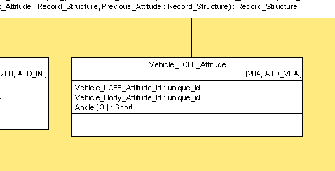
Figure 4.4.1: Array Declaration
It shall be possible to define arrays of any core or user defined type, but arrays of instance references (see 4.3, Introducing Instance References) shall not be supported, since this overloads the notion of an instance reference set.

Benefits
- Addresses a demonstrable need within Lockheed Martin.

Comments
As discussed in the previous section, there is overlap between the concept of instance handle sets and arrays. In most cases, instance handle sets (obtained by selecting across formally documented associations) are to be preferred over arrays. However, there are times (using homogenous co-ordinate geometry, for example) when a simple array is really what is required.

Implementation Plan

Schedule
The time required to implement, test and document this feature is estimated to be 25 man weeks.

Cost
The cost to develop this feature is $125,000.

Embedded Matlab Command Window Plug-in

Description
This work package delivers a simple Matlab command window inside the BridgePoint environment. The user can type Matlab commands, launch a Matlab editor and see the results of manually started calculations. Although the window is designed to look like a Matlab command window, it does not attempt to provide comprehensive Matlab support.
Figure 4.5.1 shows the Matlab command window in the lower part of the BridgePoint workbench. As with other workbench windows, the command window may be resized as required and may be maximized with a double mouse click.
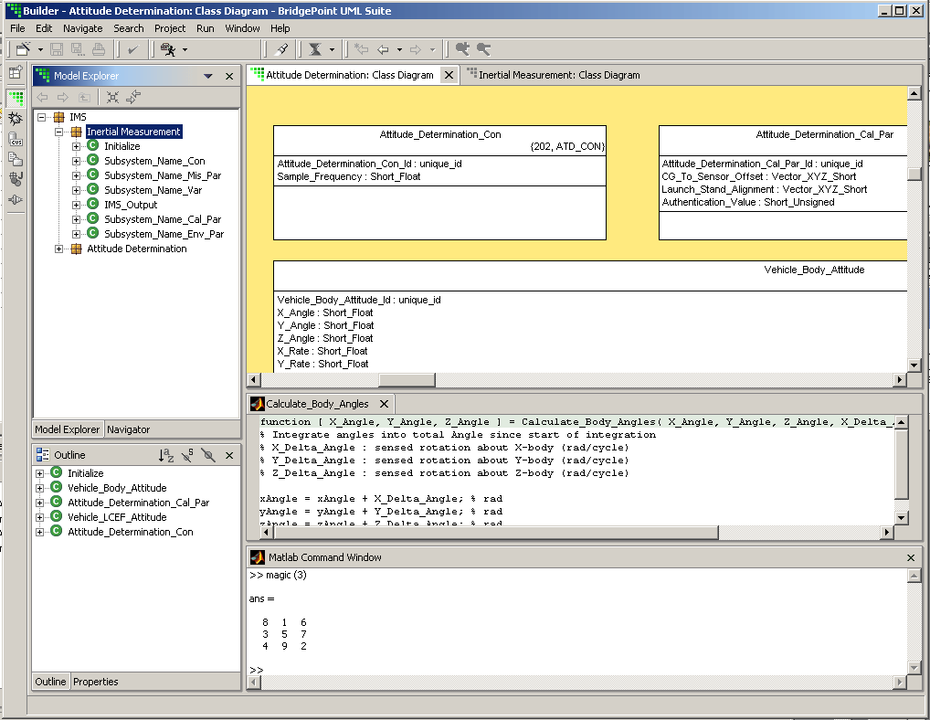
Figure 4.5.1: The embedded Matlab Command Window

Benefits
- This work provides some control over the Matlab application from within the BridgePoint environment without the cost or complexity of a full integration.
- Easy, low risk implementation.
- No dependencies on Mathworks

Discussion
This feature does not provide command completion or other Matlab command line window capabilities. A Matlab application instance fully embedded within the BridgePoint environment was considered. Due to a Matlab limitation, however, this level of integration is not considered cost effective at this time.

Implementation Plan

Schedule
The time required to implement, test and document this feature is estimated to be 16 man days.

Cost
The cost to develop this feature is $16,000.

